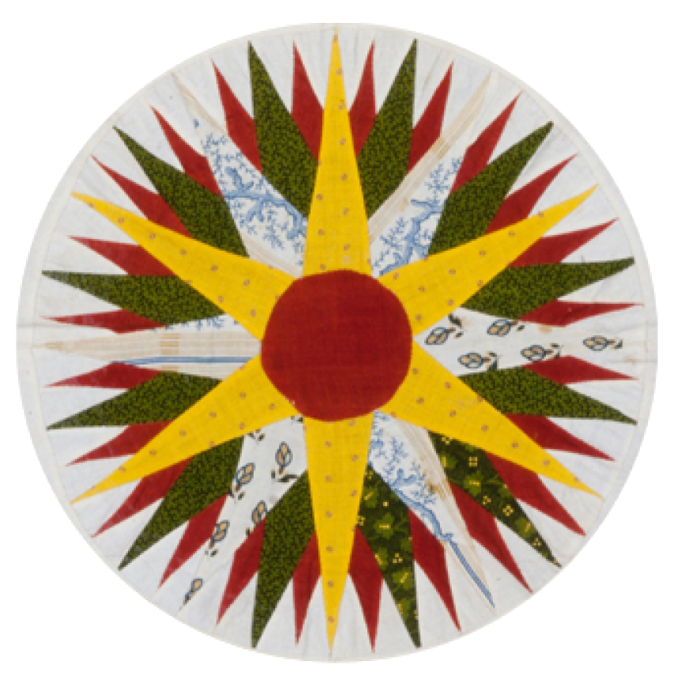

Friends of the Institute

Dear friends,

We are writing to introduce you to Friends of the Institute, the public arm of the C.G. Jung Institute of SF, and to invite you to join us in our stimulating events.

Friends of the Institute is dedicated to presenting programs that focus on Carl Jung’s insights as they are expressed through culture, fine art, literature, music, films, and related fields both in our contemporary world and throughout history. There are no prerequisites to becoming a member. You just need to be interested in exploring the ideas related to depth psychology and becoming a part of our dynamic community. There are many benefits of membership. In addition to free attendance at all our presentations, usually held both in person and on-line and recorded for later viewing, we offer book groups, Institute library access, and more.

Some of our recent programs include John Beebe’s presentation “What’s It Like To Be in Tao,” Richard Tarnas on “The Many Layered Mystery of the Human Journey,” an immersive poetry and music performance by poet Kim Rosen, and a comic monologue by Josh Kornbluth. Attached you’ll find more information in the latest issue of our newsletter.

Please go to our page at the Institute’s website to learn about all the benefits of membership: https://sfjung.org/public-programs/join-friends-of-the-institute/. You can also email us at Helene Dorian at hdorian@sfjung.org.

We look forward to hearing from you!

Warmly,

The Friends of the Institute Committee

2610 Mission Street - San Francisco, CA 94110 - (415) 771-8055 - https://sfjung.org/

